REAL TIME MULTIMODAL ENGAGEMENT DETECTION IN DIVERSE LEARNING ENVIRONMENT

Tanmay Borse, D Deepa
School of Computer Science and Engineering
Vellore Institute of Technology Vellore, India
tanmay.chhotborse2024@vitstudent.ac.in, deepa.d@vit.ac.in

ABSTRACT
The accurate and timely assessment of engagement is necessity of affective online session. User concentration a multifaceted construct encompassing behavioural, emotional and cognitive involvement, is a string predictor of success and retention. Our system utilizes a Convolutional Neural Network architecture to process facial features extracted from video streams. Engagement is quantified using a multimodal measure that fuses the Eye Aspect Ratio (EAR) and the Mouth Aspect Ratio (MAR). EAR provides a robust, non-intrusive indicator of attentiveness, while MAR offers insights into active participation and cognitive load. The CNN model is trained on a Facial Emotion Recognition (FER 2013) dataset and sample images captured through webcams. At end of session one report will be get generated that will tell how much percentage of time end user is attentive and out of focus. With EAR and MAR one buffering time window is introduced before the starting of non-attentive timer. For a dim light environment sitting candidate alarm window is created to notify them to sit in light source environment. Experimental results demonstrate that this fusion approach of dataset with new web images significantly improves the accuracy of model up to 85% from 44% and reliability of engagement detection compared to unimodal methods, enabling timely and targeted pedagogical interventions to optimize the learning experience.

KEYWORDS
Online attentiveness, Emotion detection, Distraction detection, Drowsiness detection

INTRODUCTION
This paper presents a novel approach for Real-Time Multimodal Engagement Detection in diverse learning environments, addressing the critical need for automated tools to monitor user focus and participation. Traditional methods for monitoring engagement such as direct observation or self-report are often subjective, resource intensive and difficult to scale. The rise of multimodal data collection and computer vision techniques offers a powerful solution to automate this process [12] [13]. Extended hours in front of a screen during remote meetings can severely impact user’s focus. The relaxed home atmosphere often encourages learners to multitask, pulling their attention away from the important content with activities such as checking social media, using their phones, or listening to audio. Since these distractions result in poorer academic outcomes, evaluating users' attentiveness is essential for presenter to effectively manage and monitor progress within the virtual classroom or online corporate meetings.

RELATED WORKS

If we talk about previous works done in this field automated systems are developed with features and neural networks to detect active behavioural of attendees of meeting, their facial expression that based on eyes and mouth moment, head positioning have become key elements for analysing distraction signs, sleepiness, and varied emotions [3] [4]. This part will review previous works on these three signs of human distraction which are crucial features applied for the study of this experiment.

[A] Emotion detection
In emotion-based assessment, [1] Utilized the state-of-the-art Mini-Xception CNN [8], trained on the grayscale FER-2013 dataset, to detect seven distinct emotion types (e.g., angry, happy, sad, surprise). The model achieved 66% accuracy in emotion classification on the FER-2013 dataset. The study then used the resulting emotion probabilities to calculate a concentration index by multiplying the probability of the dominant feeling by a corresponding emotional weight. This index serves to classify the user's engagement into three tiers: very engaged, nominally engaged, and not engaged at all. The research by [2] compared a Convolutional Neural Network (CNN) against a Long Short-Term Memory (LSTM) model to gauge user involvement through emotion detection. Using the DAiSEE dataset—which captures various feelings during e-learning—the models were trained to categorize four levels of emotional affect into three engagement labels: attentive, partially attentive, and inattentive. The study give result that CNN model perform well than LSTM model.

[B] Distraction detection
Distraction detection is a technique of determining behaviours denoting how attentive a candidate in a meeting. The authors of [1] utilized a two-stage approach: Haar Cascades [6] were used for initial facial and ocular detection, and the output from this detection was subsequently processed by a dedicated Convolutional Neural Network (CNN) to categorize the user's behavioural state into one of two classes: focused or distracted. Reference [7] proposes a distraction detection system that utilizes head pose (measured by roll, pitch, and yaw Euler angles) and eye direction (determined via binary thresholding) based on Dlib facial landmarks. This approach is effective for video analysis and extends to recognizing drowsiness in multiple learners.

[C] Sleepiness detection
While talking about sleepiness detection in previous studies the movement of the eyes and lips provides key data for drowsiness detection, often quantified using the Eye Aspect Ratio (EAR) [14] and Yawn Aspect Ratio (YAR) [5]. While [5] uses these ratios primarily to filter frames where the eyes are closed or a yawn occurs, [7] advances this by applying a statistical threshold to monitor the duration of drowsiness. Recognizing the limitations of relying solely on eye closure for early detection, [9] introduced a more robust method using Hierarchical Multiscale Long Short-Term Memory (HM-LSTM) to achieve higher-than-human accuracy in detecting drowsiness across all stages, accompanied by the release of the Real-Life Drowsiness Dataset (RLDD). Subsequently, [10] [11] utilized this RLDD dataset to train VGG16-based CNN models designed to predict facial fatigue through the detection of indicators like hanging eyelids and drooping mouth corners.

PROPOSED METHODOLOGY

This work details a system engineered to evaluate an individual's attentiveness or non-attentiveness during online sessions. The system mirrors a presenter's ability to gauge participant interest in an in-person setting by analyzing facial expressions, yawning, and eye movements. It operates by capturing video frames from a webcam and subjecting them to initial steps like normalization and feature engineering. It also assesses the environmental lighting to optimize frame clarity. A facial detection model first identifies the face within the captured frame. Next, the system uses the Dlib library to extract 68 facial landmarks. These landmarks are used to compute the Eye Aspect Ratio and Mouth Aspect Ratio to detect sleepiness and yawning. A trained Convolutional Neural Network (CNN) then processes these features to ultimately predict the user's state of attentiveness and also determine the surrounding light environment.

DATASET

The original FER2013 dataset consists of approximately 35,887 grayscale images of $48 \times 48$ pixels, categorized into seven emotions: Angry, Disgust, Fear, Happy, Sad, Surprise, and Neutral. Initially, some emotion classes within the FER2013 dataset lacked a sufficient number of images for optimal model training. So additional new sample images taken from web. These new samples were integrated into the FER2013 classes that had fewer original images, effectively increasing the sample size for those categories. To enhance the model's performance and robustness in unconstrained, real-world conditions augmentation is carried out during training phase.
METHODOLOGY

In this section the methodology used in the proposed work from data pre-processing to end results are discussed.
[1] Data pre-processing and Augmentation
This stage for pre-processing the data before it is being use in the model training. To maintain the data similarity between pixel values of 0 to 255 normalization is a needed step. Augmentation is step that helps to do pixel level transformation on images to avoid repetitiveness in data and provide some type of variety during epochs.
[1.1] Data pre-processing and Normalization
Before training the CNN model using the combined FER2013 and webcam images, the data required pre-processing. Any additional colored images captured from webcams were first converted to grayscale to maintain consistency with the FER2013 dataset, which also helped reduce computational load. The images then underwent a normalization step where all pixel values, originally in the range [0, 255], were scaled to the range [0, 1] by dividing by 255.0; this standardization was performed to accelerate convergence during the training phase. Finally, every image was resized to a fixed input dimension of 48 X 48 pixels to match the requirements of the selected CNN architecture.

[1.2] Data Augmentation
To prevent overfitting and substantially enhance the model's ability to generalize to real-time video feeds, we utilized data augmentation. This crucial step involved applying various geometric and pixel-level transformations to the training images. For instance, we used rotation by various angles to account for user head movements, and adjusted brightness and contrast to simulate a diverse range of lighting conditions. Additionally, techniques like zoom and shearing were applied to mimic minor camera movements or changes in distance from the user.
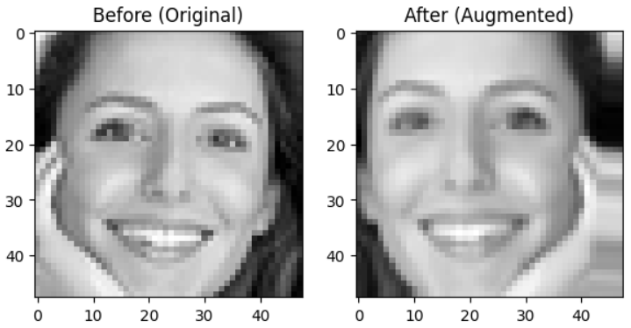
Fig. Image augmentation (horizontal flip)

[2] Model
This section details the specific architecture, configuration, and training regimen of the Convolutional Neural Network (CNN) used for the initial feature extraction and emotion classification component of the multimodal engagement detection system.

[2.1] CNN Model Architecture
The model utilizes a sequential architecture comprising four convolutional blocks, followed by fully connected layers. The design emphasizes depth and the inclusion of regularization techniques to ensure robust feature learning and prevent overfitting. They work sequentially to transform the raw pixel data of the input image (48×48×1) into high-level, abstract features that the final dense layers can use for classification.
The network employs a standard pattern of Convolution → Batch Normalization → ReLU Activation → Pooling → Dropout.
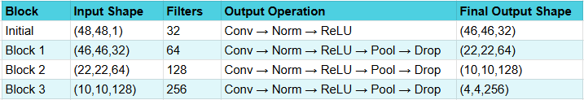
The Convolutional (Conv2D) layers initiate feature extraction by applying a learned set of filters across the input image. These filters progressively increase in number (from 32 to 256), enabling deeper layers to recognize increasingly complex patterns. Batch Normalization stabilizes the learning process by standardizing layer activations. The ReLU (Rectified Linear Unit) function then introduces essential non-linearity, which allows the network to model the complex, non-linear relationships inherent in facial expressions, something linear models cannot achieve. For efficiency, a 2×2 Max Pooling layer reduces both the computation required and the overall parameter count. Finally, 25% Dropout acts as a powerful regularize, randomly silencing units during training to force the network to develop a distributed and more robust feature representation, thereby effectively combating overfitting.
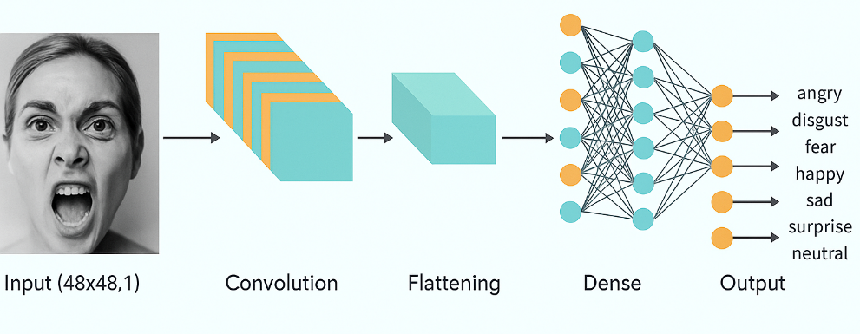
Fig. CNN model Architecture

[2.2] Model compilation and Training configuration
The Adam optimizer was chosen for its adaptive learning rate functionality, and it was initially set to a cautious value of 0.0001. This slow rate was deliberate, aiming to allow the deep network to fine-tune its weights and prevent the Categorical Cross-Entropy loss (appropriate for the seven-class emotion classification) from experiencing large, destabilizing oscillations. Training was conducted using an augmented and resampled dataset (X_resampled​, Y_resampled) to correct the class imbalance inherent in the dataset. A data generator was utilized to efficiently stream data and apply real-time augmentation during training. Model performance was consistently assessed using a separate, static validation set (Xval​, Yval​). Furthermore, a ModelCheckpoint callback was implemented to save the model weights to best_model_v2.h5 only when an improvement in validation accuracy was observed.

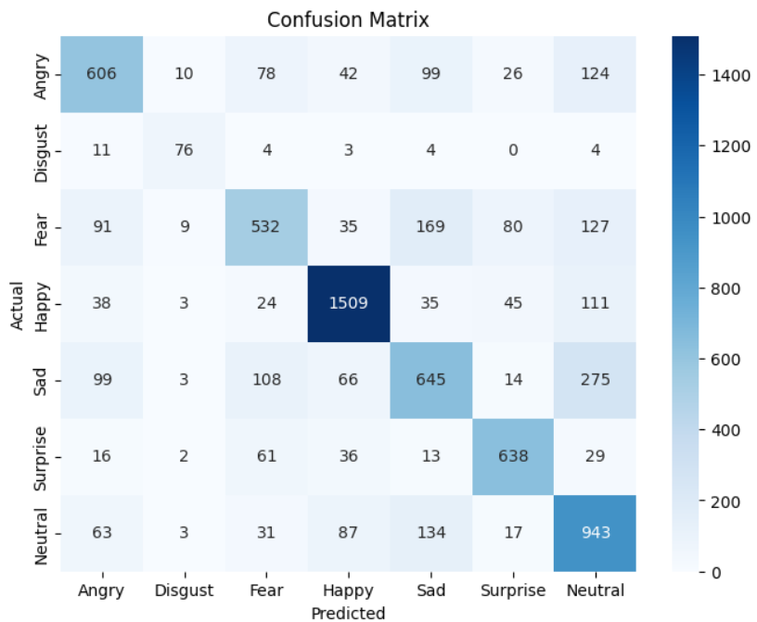
Fig. Result of CNN trained model for each class

[3] Facial Landmark Extraction and Aspect Ratio Calculation
[3.1] Dlib for facial landmarks
For real-time engagement detection, the core features—Eye Aspect Ratio (EAR) and Mouth Aspect Ratio (MAR)—are calculated directly from video frames using facial landmarks, which is significantly faster than running the full image through the CNN for every frame. The Dlib library, along with its pre-trained 68-point shape predictor, is employed for real-time face and landmark detection. Specifically, the Dlib Histogram of Oriented Gradients (HOG)-based face detector first identifies the face's bounding box in each video frame. Then, the 68-point predictor is applied to the detected face area, mapping specific points to key facial features, including the eyes and mouth, from which the EAR and MAR are computed.

[3.2] Sleepiness detection
To detect the sleepiness of user capture through frame we are using the Eye Aspect Ratio (EAR). It is a scalar metric used to determine state of an eye either close or open. It is calculated using the distances between specific sets of six landmarks around each eye by taking ratio between vertical distances to horizontal distances. For a set of eye landmarks P1, P2, P3, P4, P5, P6. Where P1​and P4​are horizontal extremes, and P2, P3, P5, P6​are vertical as shown in fig 1, the EAR is defined as:

$$EAR =\frac{\left(\left|\left|P_{2} - P_{6}\right|\right|+ \left|\left|P_{3} - P_{5}\right|\right|\right)}{\left(2 x \left|\left|P_{1} - P_{4}\right|\right|\right)}$$
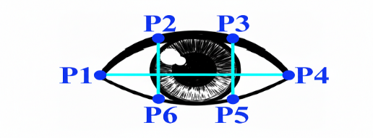
Fig 1. Eye Aspect Ratio

The Eye Aspect Ratio (EAR) is used as an indicator of an attendee's attentiveness. As seen in the figure (which describes the EAR calculation), when the eye is closed, the vertical distances between the landmarks (P2 and P6, and P3 and P5) decrease. This results in a lower numerator compared to the denominator in the EAR formula, yielding a low EAR value. A low EAR thus indicates a closed eye, which is interpreted as non-attentiveness or drowsiness. Conversely, a high EAR signifies an open eye and suggests attentiveness. To make a final decision, the EAR is calculated for both eyes, and the average of the two values is compared against a defined threshold, typically set in the range of 0.2 to 0.3, which can vary slightly depending on individual eye size.

[3.3] Drowsiness Detection
Mouth Aspect Ratio is used to detect the drowsiness of a user by calculating its MAR value. It identifies the opening of the mouth, serving as an indicator of activeness of an end user, either he is speaking or yawning. MAR is given by the equation

MAR =$\frac{\left|\left|P_{2}- P_{4}\right|\right|+|\left|P_{6}- P_{8}\right||}{\left|\left|P_{1}- P_{3}\right|\right|+|\left|P_{5}- P_{7}\right||}$

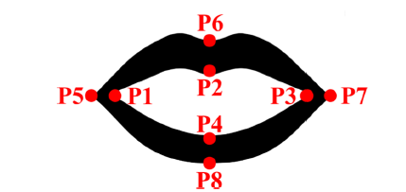
Fig 2. Mouth Aspect Ratio

A high MAR value indicates the mouth is significantly open (e.g., speaking or yawning), the value comes high if P6 and P8, and P2 and P4 values are large as compared to P1 P3 and P5 P7. If distance in vertical points is high resulting high value in numerator. And hence horizontal points comes close then giving low value at denominator. The result in compared with Threshold value. This situation indicating yawning providing a valuable cue for active or fatigued states.

These two real-time features, EAR and MAR, are then fused with the contextual emotional features extracted by the trained CNN to create the final multimodal engagement prediction model

REAL-TIME PREDICTION PROCESS

The system operates in a continuous, real-time loop for multimodal engagement detection. Initially, the webcam feed is captured frame-by-frame. Before processing a frame, we will check the user weather user is seated in a light environment to video capture can generate clear images, if user is in low light environment then create a alter window on screen to request the user to seat in better light environment. Then each frame is simultaneously processed by two parallel pipelines. In the Computer Vision Pipeline, the Dlib library is used to detect the user's face and locate 68 facial landmarks. These landmarks are immediately used to calculate the Eye Aspect Ratio (EAR) and the Mouth Aspect Ratio (MAR) using geometric formulas, providing instantaneous, low-latency indicators of attentiveness and active participation or drowsiness.
Simultaneously, the Emotion Recognition Pipeline extracts the detected face region, converts it to grayscale, normalizes, and resizes it to 48×48 pixels. This processed image is then fed into the pre-trained CNN model, which outputs a probability distribution across seven emotion classes. Finally, the system executes the Fusion and Decision Module, where the real-time EAR and MAR values are combined with the CNN's emotion probabilities. This integration allows for a robust, multimodal assessment: for example, low EAR combined with a 'Sad' emotion probability may indicate disengagement or confusion, while a moderate EAR and high MAR (indicating speech) suggests high active engagement.
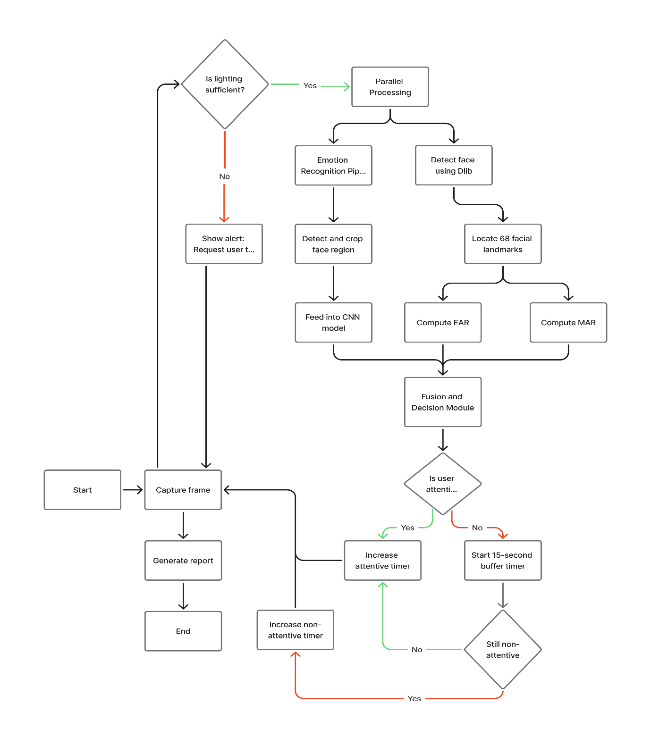
This module processes the combined features to classify the user's state as either attentive or non-attentive. If the user is classified as attentive, their accumulated attentiveness time is increased. If classified as non-attentive, a 15-second buffer time begins. If the user remains non-attentive after this buffer, the non-attentive timer starts incrementing. At the conclusion of the session, the system generates a report detailing the percentage of total time the user was actively concentrating versus the percentage of time they were not.

RESULT AND METRICS

Compare to previously trained VGG16 model, pre-trained on the FER2013 dataset for transfer learning. We modified this base model by removing its original input and output layers and adding our own corresponding layers to suit the specific requirements of our application. No new data was added to the original FER2013 dataset during this process.
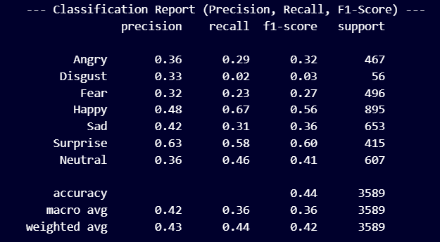
Fig. VGG16 model classification report
Based on the classification report, the model's overall performance is quite modest, achieving an accuracy of only 44%. This low accuracy is rooted in the model's highly imbalanced performance across different emotion classes. Specifically, the model exhibits very low recall (the ability to correctly identify positive instances) for several key emotions, notably Disgust (0.02) and Angry (0.29), indicating a significant inability to detect these emotions when they are present. Furthermore, the precision (the ability to avoid false positives) is also low for classes like Fear (0.32) and Disgust (0.33). While the model performs reasonably well on the Surprise class with a high F1-score of 0.60 (precision 0.63, recall 0.58) and shows decent recall for Happy (0.67), the generally poor and uneven scores across most classes especially reflected in the macro average F1-score of 0.36 pull the overall accuracy down significantly. The low and uneven performance suggests the model may be failing to learn distinct, robust features for several of the less frequent or more challenging-to-classify emotions.
Metric | Model 1 – Our model | Model 2: VGG16 Baseline
Dataset Used | FER2013 + Webcam Augmented | FER2013 (Original)
Input Size | 48×48 (grey) | 48×48 (grey)
Precision (Avg) | 0.69 | 0.43
Recall (Avg) | 0.69 | 0.44
F1-Score (Avg) | 0.68 | 0.42
Accuracy | 0.69 | 0.44

Table: Model comparison

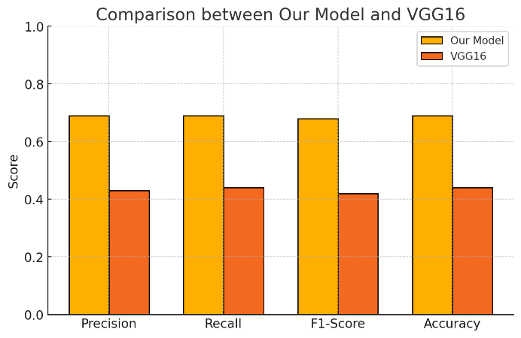
Fig comparison between two models
The CNN model's performance in classifying the seven basic emotions was rigorously evaluated, achieving an overall Training accuracy of 0.84996 (~85%) on the training dataset and 0.6906 (~70%) on test data of 7,178 samples. The model demonstrates high proficiency in recognizing certain states, most notably Happy, which achieved the highest scores with a precision of 0.86, recall of 0.84, and an f1-score of 0.85. Similarly, Surprise (f1=0.79) and Disgust (f1=0.73) were classified with high reliability. However, the model struggled a bit with negative and ambiguous emotions. Sad exhibited the lowest performance, with a low recall of 0.53 and an f1-score of only 0.56. Fear and Angry also showed comparatively lower f1-scores (0.57 and 0.63, respectively), suggesting difficulty distinguishing between these subtle negative expressions. The Neutral class, despite having a high support count (1,278), also shows a notable imbalance between precision (0.58) and recall (0.74).
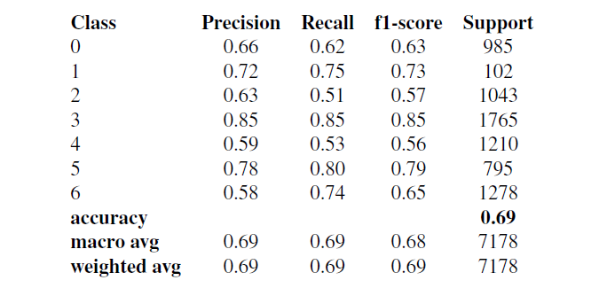
Fig. Our model classification report

CONCLUSION AND FUTURE WORK

This paper presented a robust, real-time multimodal approach for engagement detection tailored for diverse learning environments. By fusing the power of a Convolutional Neural Network for emotion classification (trained on FER-2013 and supplementary data) with the computationally efficient Eye Aspect Ratio and Mouth Aspect Ratio features, our system successfully quantifies student attentiveness and participation. The architecture demonstrated solid performance on the emotion component, achieving 70% overall accuracy and particularly strong results for the 'Happy' state (f1=0.85). By integrating EAR and MAR derived from Dlib facial landmarks we successfully established a low-latency, generalized framework capable of distinguishing between focused attention, distraction, and active engagement.

A primary limitation is the model's reduced accuracy for subtle negative emotions, even with dataset resampling. Addressing this requires a future focus on creating and refining more balanced training datasets. Additionally, the current approach relies solely on visual analysis of the end-user. The model's utility could be greatly enhanced by incorporating the audio modality, which provides essential context on user engagement, differentiating between distracting ambient noise and relevant, active speech.

REFERENCES

[1] Sharma, P., Joshi, S., Gautam, S., Maharjan, S., Khanal, S.R., Reis, M.C., Barroso, J. and de Jesus Filipe, V.M., 2022, August. Student engagement detection using emotion analysis, eye tracking and head movement with machine learning. In International conference on technology and innovation in learning, teaching and education (pp. 52-68). Cham: Springer Nature Switzerland.
[2] Shamika, U.B.P., Weerakoon, W.A.C., Panduwawala, P.K.P.G. and Dilanka, K.A.P., 2021, September. Student concentration level monitoring system based on deep convolutional neural network. In 2021 International Research Conference on Smart Computing and Systems Engineering (SCSE) (Vol. 4, pp. 119-123). IEEE.
[3] A-masiri, P. and Kerdvibulvech, C., 2023. Anime face recognition to create awareness. International Journal of Information Technology, 15(7), pp.3507-3512.
[4] Azeez, R.A., Jamil, A.S. and Mahdi, M.S., 2023. A Partial Face Encryption in Real World Experiences Based on Features Extraction from Edge Detection. Int. J. Interact. Mob. Technol., 17(7), pp.69-81.
[5] Shah, N.A., Meenakshi, K., Agarwal, A. and Sivasubramanian, S., 2021, January. Assessment of student attentiveness to e-learning by monitoring behavioural elements. In 2021 International conference on computer communication and informatics (ICCCI) (pp. 1-7). IEEE.
[6] Viola, P. and Jones, M., 2001, December. Rapid object detection using a boosted cascade of simple features. In Proceedings of the 2001 IEEE computer society conference on computer vision and pattern recognition. CVPR 2001 (Vol. 1, pp. I-I). Ieee.
[7] Khan, R. and Debnath, R., 2020. Human distraction detection from video stream using artificial emotional intelligence. International Journal of Image, Graphics and Signal Processing, 14(2), p.19.
[8] Fatima, S.A., Kumar, A. and Raoof, S.S., 2021. Real time emotion detection of humans using mini-Xception algorithm. In IOP conference series: materials science and engineering (Vol. 1042, No. 1, p. 012027). IOP Publishing.
[9] Ghoddoosian, Reza, Marnim Galib, and Vassilis Athitsos. "A realistic dataset and baseline temporal model for early drowsiness detection." In Proceedings of the ieee/cvf conference on computer vision and pattern recognition workshops, pp. 0-0. 2019.
[10] T. Gapi, K., Matthew G. Magbitang, R. and F. Villaverde, J., 2021, March. Classification of Attentiveness on Virtual Classrooms using Deep Learning for Computer Vision. In Proceedings of the 2021 11th International Conference on Biomedical Engineering and Technology (pp. 34-39).
[11] Khandare, H., Rajak, A. and Tripathi, R., 2023, July. A deep learning framework for non-intrusive driver drowsiness detection. In 2023 14th International Conference on Computing Communication and Networking Technologies (ICCCNT) (pp. 1-5). IEEE.
[12] Voulodimos, A., Doulamis, N., Doulamis, A. and Protopapadakis, E., 2018. Deep learning for computer vision: A brief review. Computational intelligence and neuroscience, 2018(1), p.7068349.
[13] Szeliski, R., 2022. Computer vision: algorithms and applications. Springer Nature.
[14] Mehta, S., Dadhich, S., Gumber, S. and Jadhav Bhatt, A., 2019, February. Real-time driver drowsiness detection system using eye aspect ratio and eye closure ratio. In Proceedings of international conference on sustainable computing in science, technology and management (SUSCOM), Amity University Rajasthan, Jaipur-India.

